C PROGRAM FOR MULTIPLICATION OF 2 MATRICES.

#include<stdio.h>

int main()

{

int r1,c1,r2,c2,i,j,k;

printf("Enter Number of rows in matrix 1 \n");

scanf("%d",&r1);

printf("Enter Number of columns in matrix 1 \n");

scanf("%d",&c1);

printf("Enter Number of rows in matrix 2 \n");

scanf("%d",&r2);

printf("Enter Number of columns in matrix 2 \n");

scanf("%d",&c2);

if(c1!=r2)

{

printf("Condition for multiplication not followed. \n");

return 0;

}

int m1[r1][c1],m2[r2][c2],a[r1][c2];

for(i=0;i<r1;i++)

{

for(j=0;j<c2;j++)

{

a[i][j]=0;

}

}

printf("Enter elements in matrix 1 \n");

for(i=0;i<r1;i++)

{

for(j=0;j<c1;j++)

{

scanf("%d",&m1[i][j]);

}

}

printf("Enter elements in matrix 2 \n");

for(i=0;i<r2;i++)

{

for(j=0;j<c2;j++)

{

scanf("%d",&m2[i][j]);

}

}

for(i=0;i<r1;i++)

{

for(j=0;j<c2;j++)

{

for(k=0;k<c1;k++)

{

a[i][j]=a[i][j]+(m1[i][k]\*m2[k][j]);

}

}

}

for(i=0;i<r1;i++)

{

for(j=0;j<c2;j++)

{

printf("%d \t",a[i][j]);

}

printf("\n");

}

return 1;

}

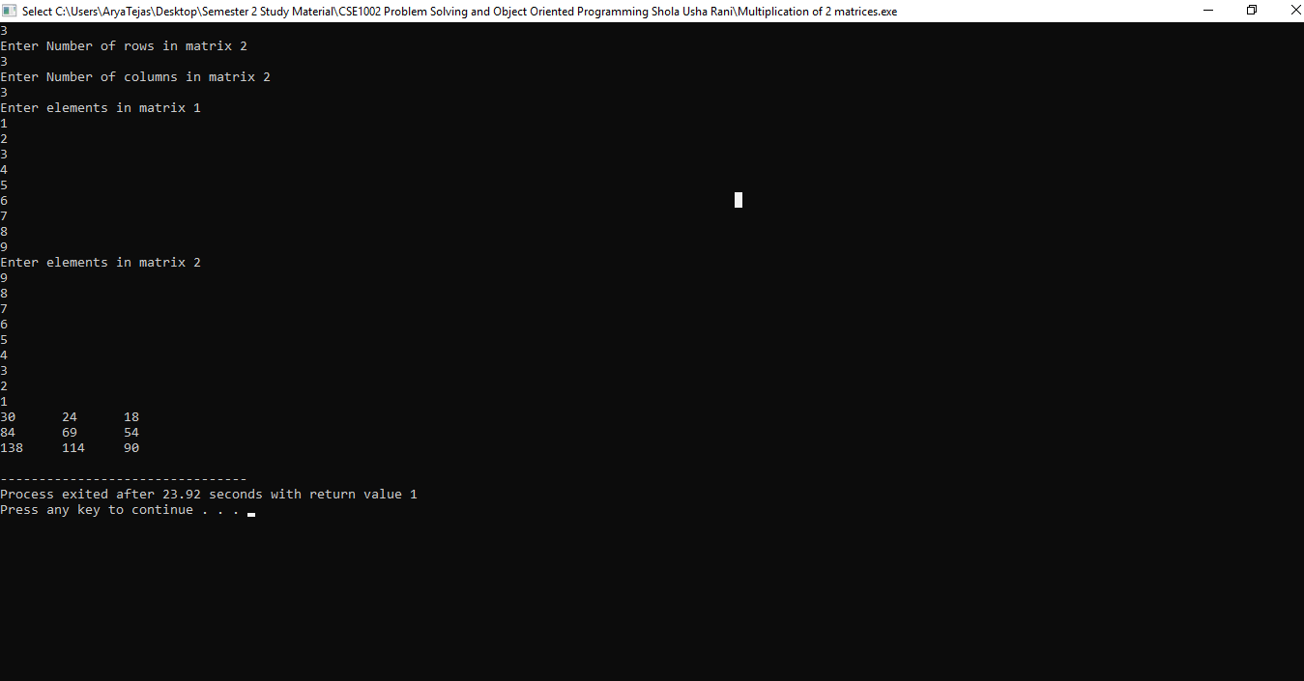

C PROGRAM TO PRINT CHARACTER CODE AND INTEGER CODE.

#include<stdio.h>

main()

{

char a[5]={'w','e','r','t','y'};

int b[5]={12,13,23,34,45},i;

printf("Character Code \t Integer code \n");

for(i=0;i<5;i++)

{

printf("%c \t\t\t %d \n",a[i],b[i]);

}

}

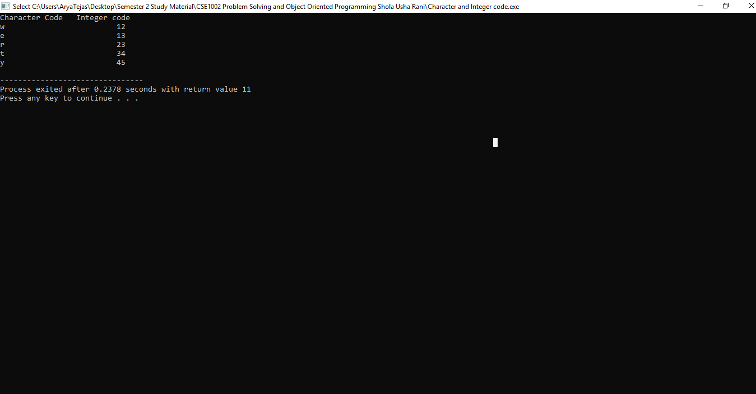

C PROGRAM TO FIND EVEN AND ODD DIGITS IN ARRAY.

#include<stdio.h>

main()

{

int i,a[10],evencount=0,oddcount=0;

printf("Enter 10 values in Array\n");

for(i=0;i<10;i++)

{

scanf("%d",&a[i]);

}

for(i=0;i<10;i++)

{

if(a[i]%2==0)

{

evencount++;

printf(",%d\n",a[i]);

}

}

printf("Number of even digits in array=%d \n",evencount);

for(i=0;i<10;i++)

{

if(a[i]%2!=0)

{

oddcount++;

printf(",%d\n",a[i]);

}

}

printf("Number of odd digits in array=%d\n",oddcount);

}

